Team Report - Day 1 - 2 (SRISTI Summer School)

Group 1

Team Members: Sairaj Khope, Sumedh Supe, Tanisha Sushil, Shivani Lal, Keyur Undaviya, Pallav Maru, Marthias Dockweiler, Pooja
Kids: Amardeep, Dhanraj, Prateek, Raksha, Viswa
Faculty Coordinator: Nischith Acharya
Coordinators: Rajvi Prajapat, Hiral Shastri and Sagar Panchal

Field Visit - I (Broom Making Industry at Chandola, Ahmedabad)

Field Description

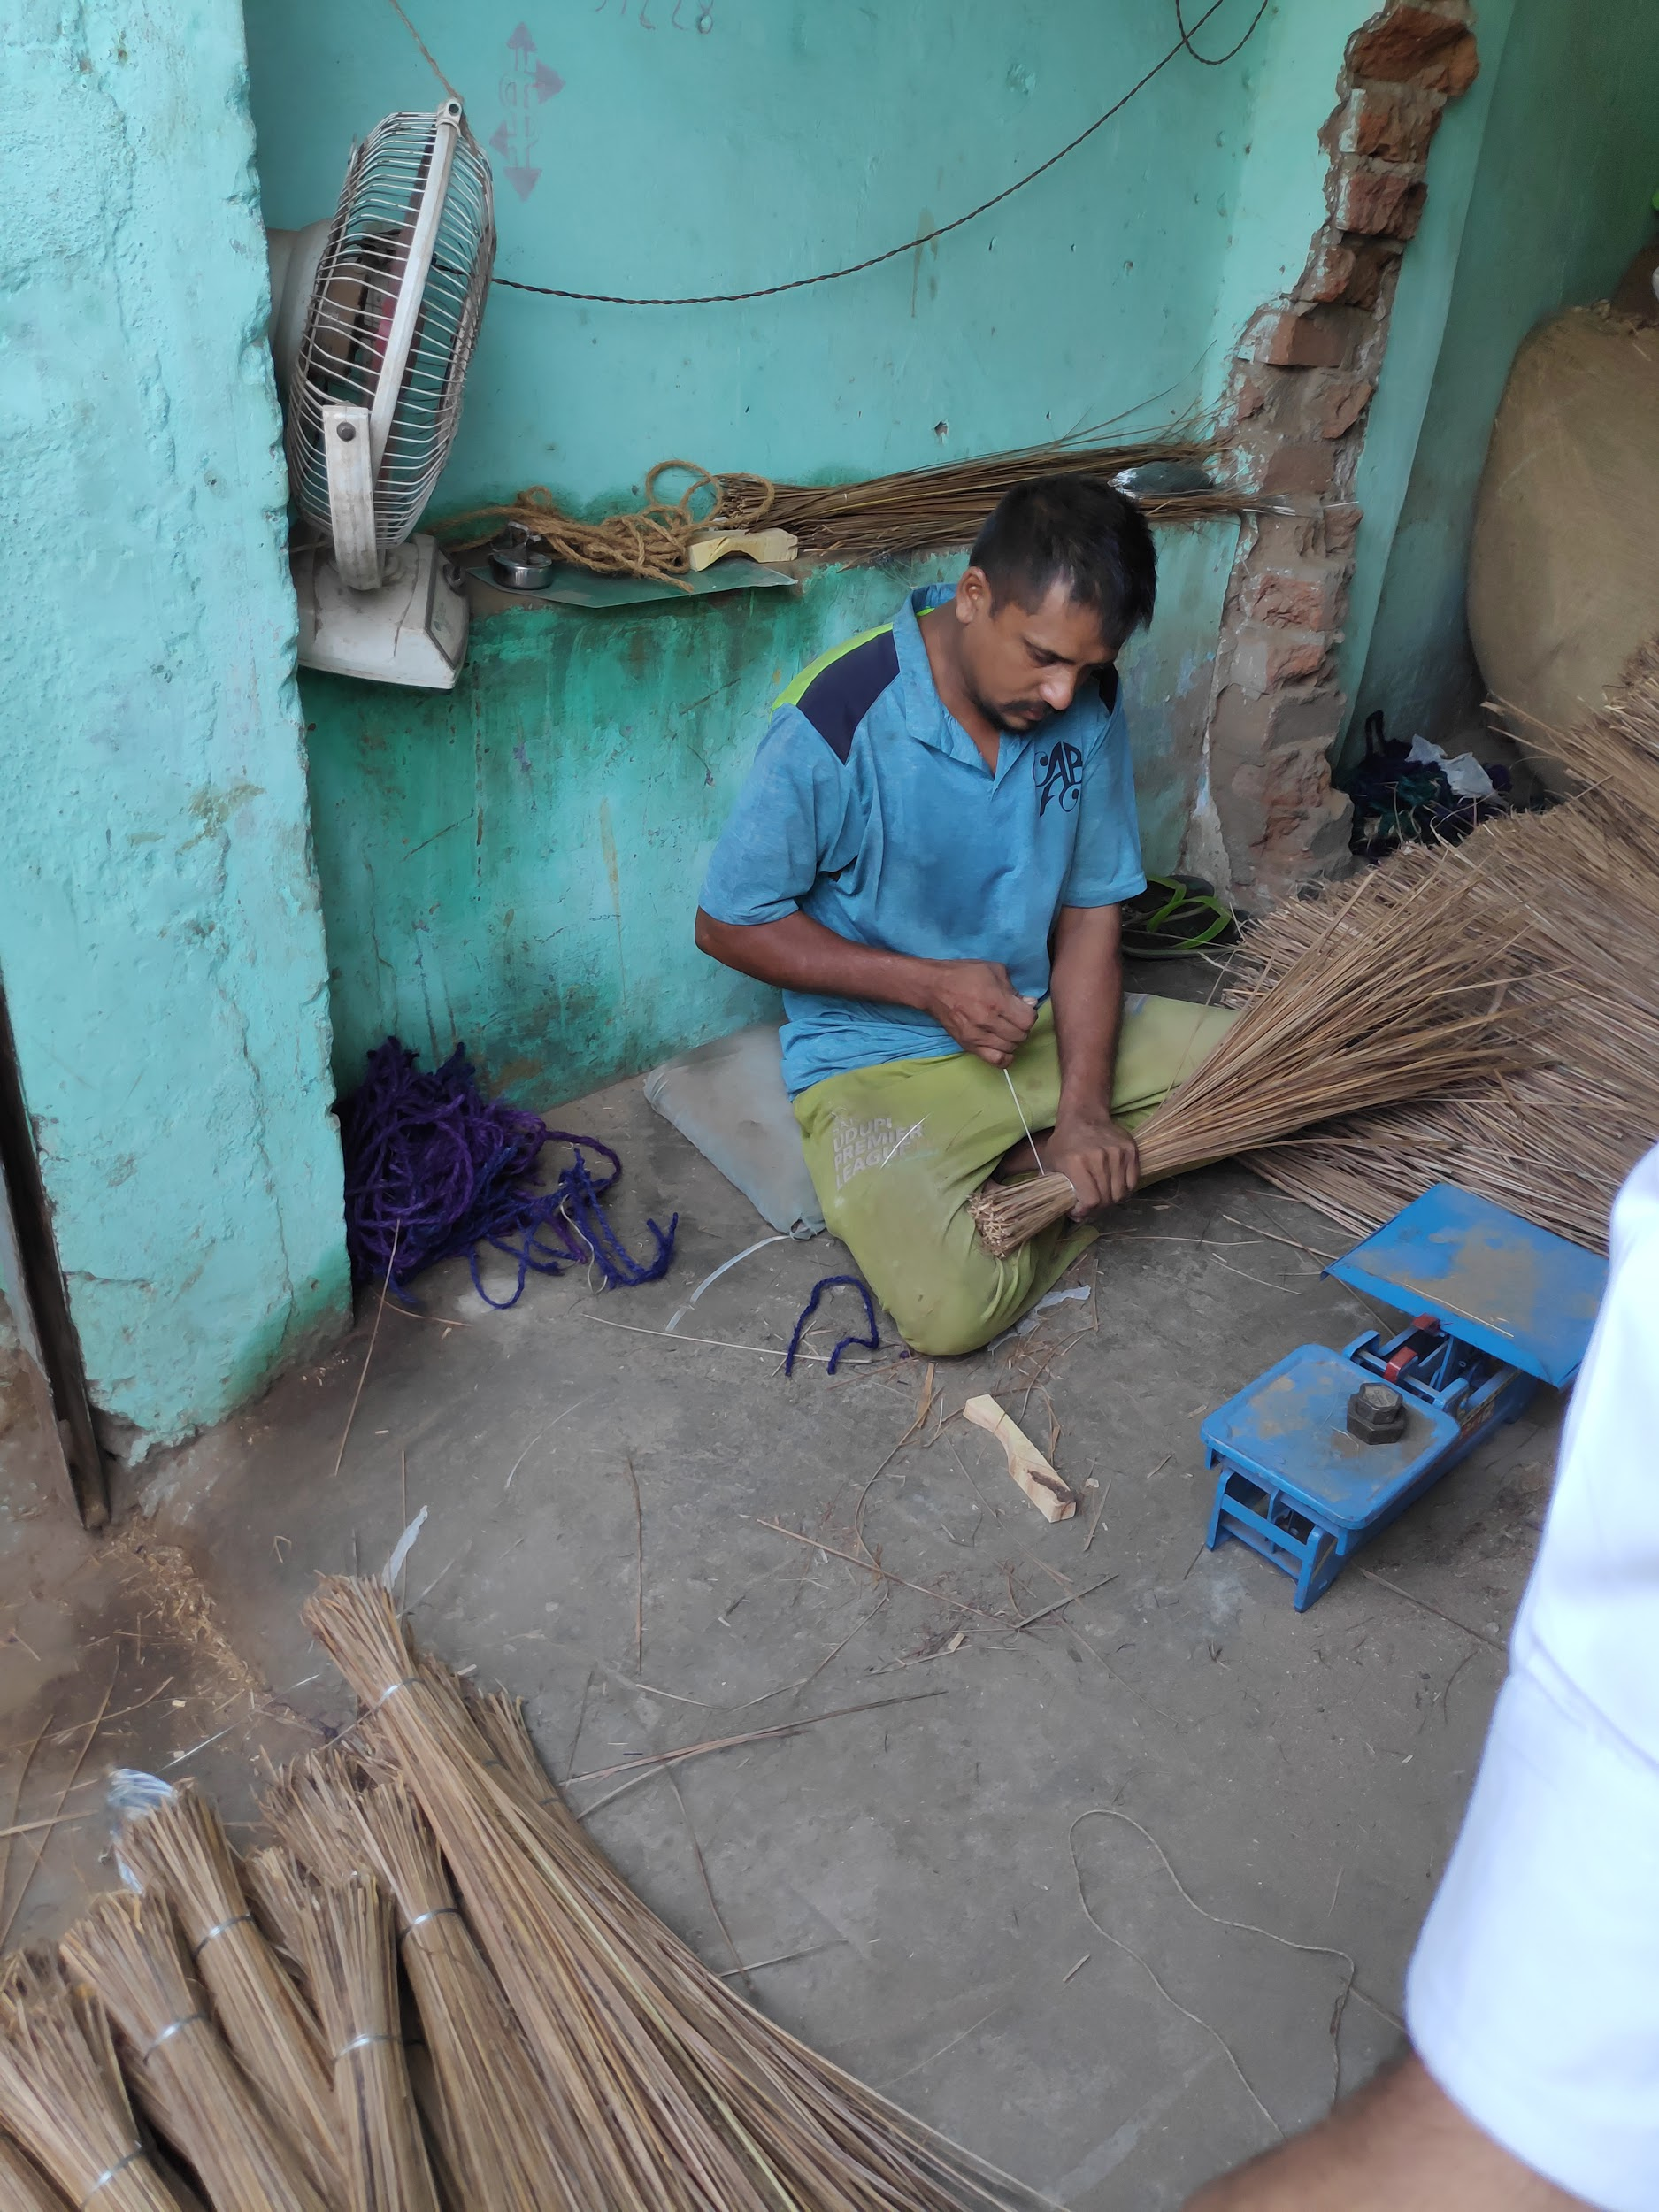
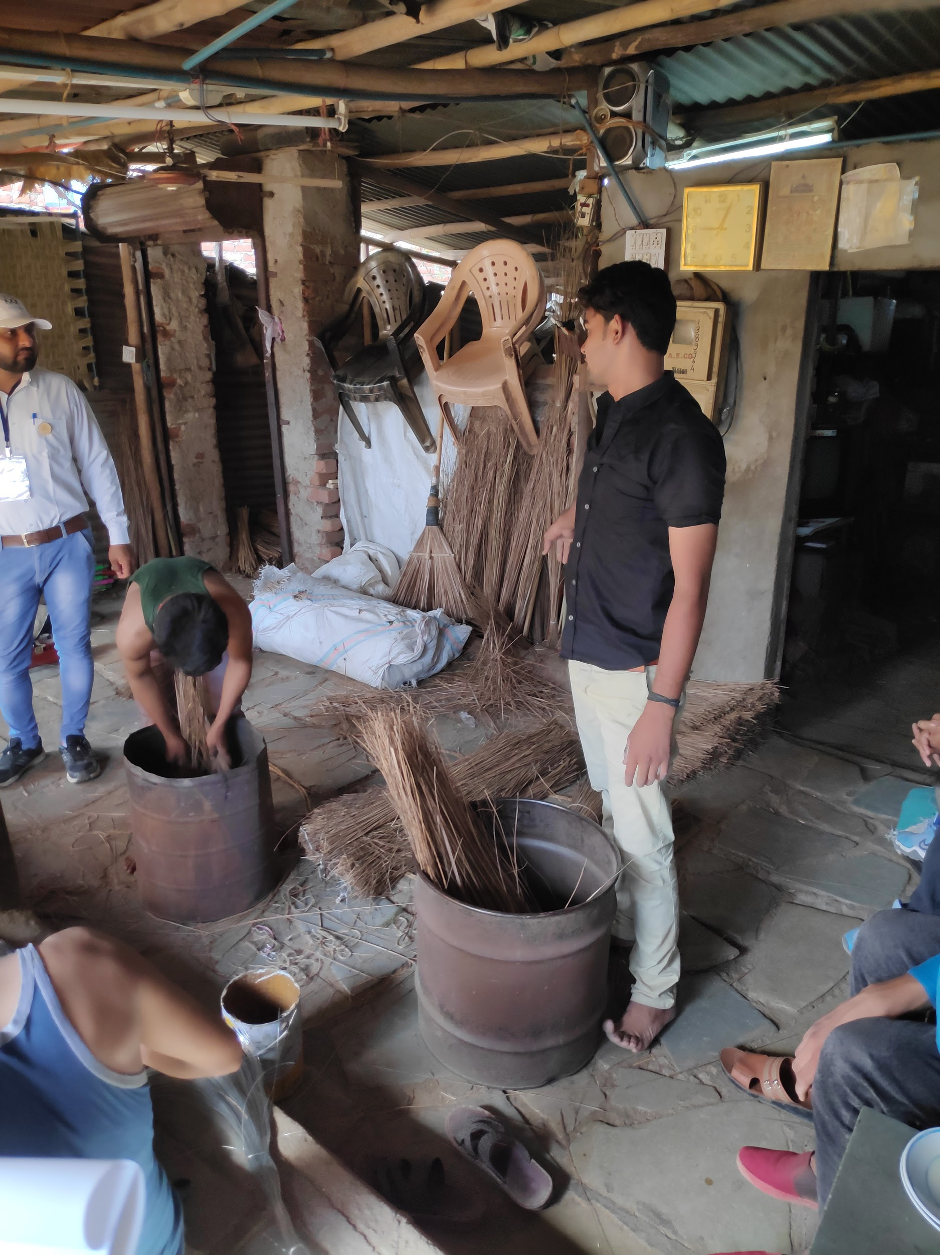

Chandola is known for small scale wholesale manufacturing of brooms. We visited 3 different broom making shops along with one raw material(plastics) supplier for the industry. The first shop that we visited specialised in heavy duty coconut fibre brooms. The process of manufacturing involved manually sorting and dusting the hay required for making brooms (with raw material sourced from Kerala, Tamil Nadu and Karnataka), Wire binding and wood chip reinforcement for final packaging of the brooms and adding the type of handle (Jute based or plastic based for general orders, Bamboo stick for specific usage for Municipality workers) respectively. The brooms are priced at Rs. 15 - 20 on avg. depending on the type of handle used. The workers make wages of Rs. 250 per bundle and daily production per worker is 3 bundles which is approximately 570-580 brooms. Each bundle costs 1100 Rs. and considering the daily cost of raw materials per worker around 600 Rs. the total profit of the shop per worker comes to around 3300 Rs.

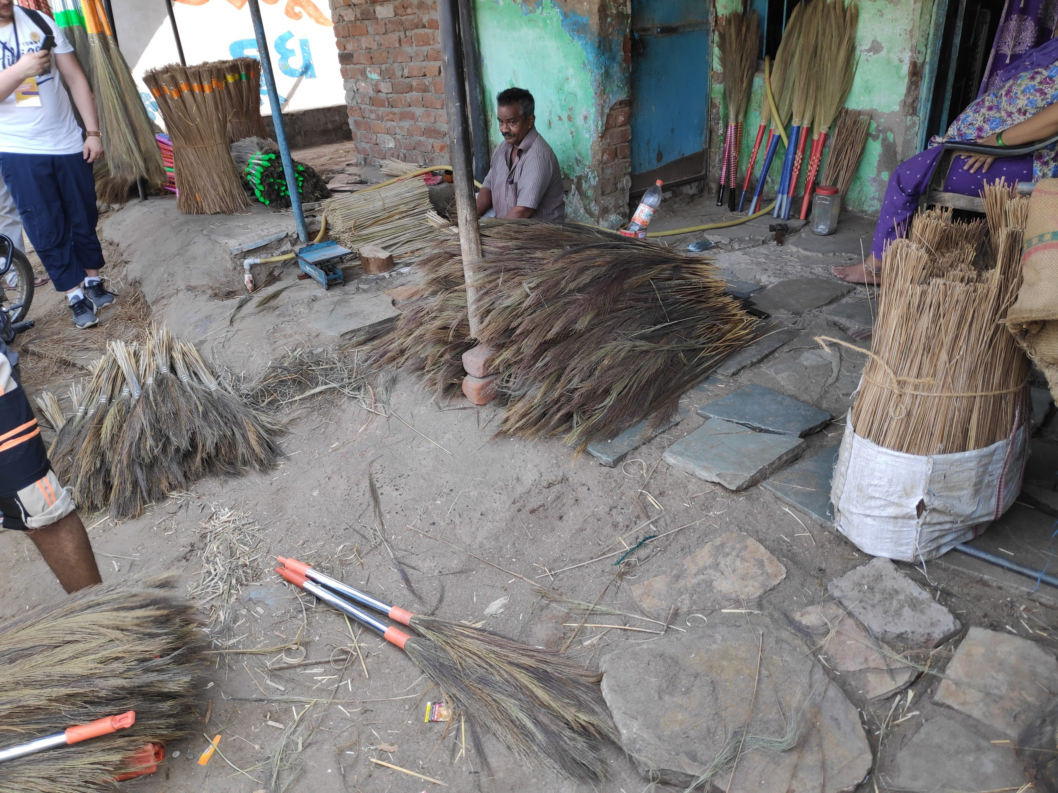
The second shop that we visited specialised in flower brooms made with the date palms leaves brought from Assam. The broom making procedure was sort of similar, and as most of these brooms were made for home usage. They also had a long handle with a decorated grip either made from tape, metal or plastic to make it aesthetically pleasing. The broom is made by a man while the aesthetic packaging like the plastic wrapping is done by women. The man takes a charge of 1 Rs. as labor cost while the women charge 50 paisa. Daily output of the shop is 300 units and the broom is sold to the retailer at 20 Rs. which makes the shop a meagre profit of 300 Rs. considering the raw material cost of Rs. 16 per broom of the Assam hay.

The third shop gave us a bit more insight into the wholesale market and the sale of brooms in it. The shop had a larger commercial space than the previous two shops that we had visited and employed people from the outside to work in it. This shop made all sorts of brooms ranging from the heavy duty ones to the ones used by municipal corporation workers. The prices of brooms ranged from Rs. 30 - Rs. 60. The worker gets a fixed fee of Rs. 2 per broom and their daily production is 200 units which amounts to 400 Rs. per day for the worker.

List Of Problems

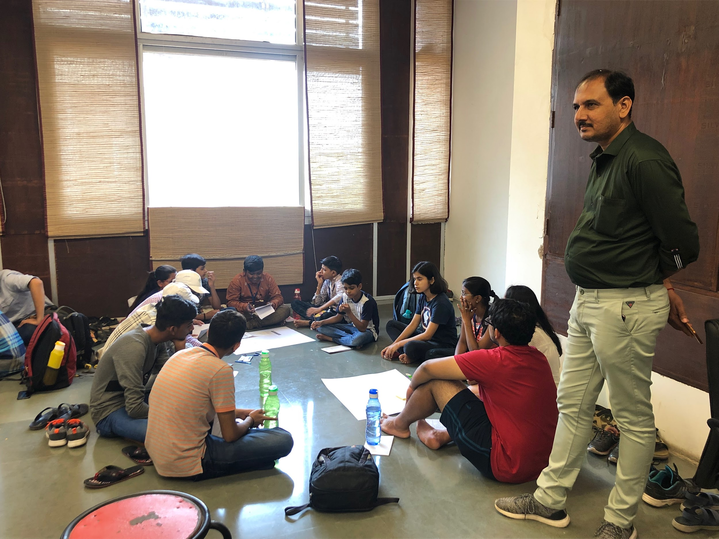
The team discussing problems with kids at KCG

- Manual sorting and bundling of the coconut hay resulted in removal of around 10% of material as waste and high amounts of dust generation along with increase in time taken to make a broom due to a feedback loop process to have the exact weight of materials to make the broom.
- Coconut fibers have splinters that can easily penetrate the skin and cause infections.
- Wire cutting to bind the broom together is also done manually and by hand which is painful due to the cuts inflicted when process is speed up and without any money for medical assistance it can easily cause infections.
- Workers are paid very less just enough to last 3 meals despite the long hours they put in for work as they are unable to produce considerable output.
- There is unnecessary competition from multiple shops manufacturing brooms which reduces prices even further and puts more financial strain on shops and workers.
- Raw material seller had to sell plastic handles for a relatively high price as all of it was procured from Delhi which added Transport costs whereas buying a machine for production required at least 10 Lakhs.
- All the brooms had handles made of plastic in their production process which is unsustainable in the long run and puts more strain on the already expanding garbage management problem in the country. There is a need for finding more biodegradable and sustainable materials that are cheaper to produce than plastic.

Solutions
- Kids
- Focused on the design of a machine made for winding wire around the broom using a DC Motor and an iron shaft which was indented slightly with a wire wound the indented part of the shaft which rotated to wind the wire around the broom bundle.

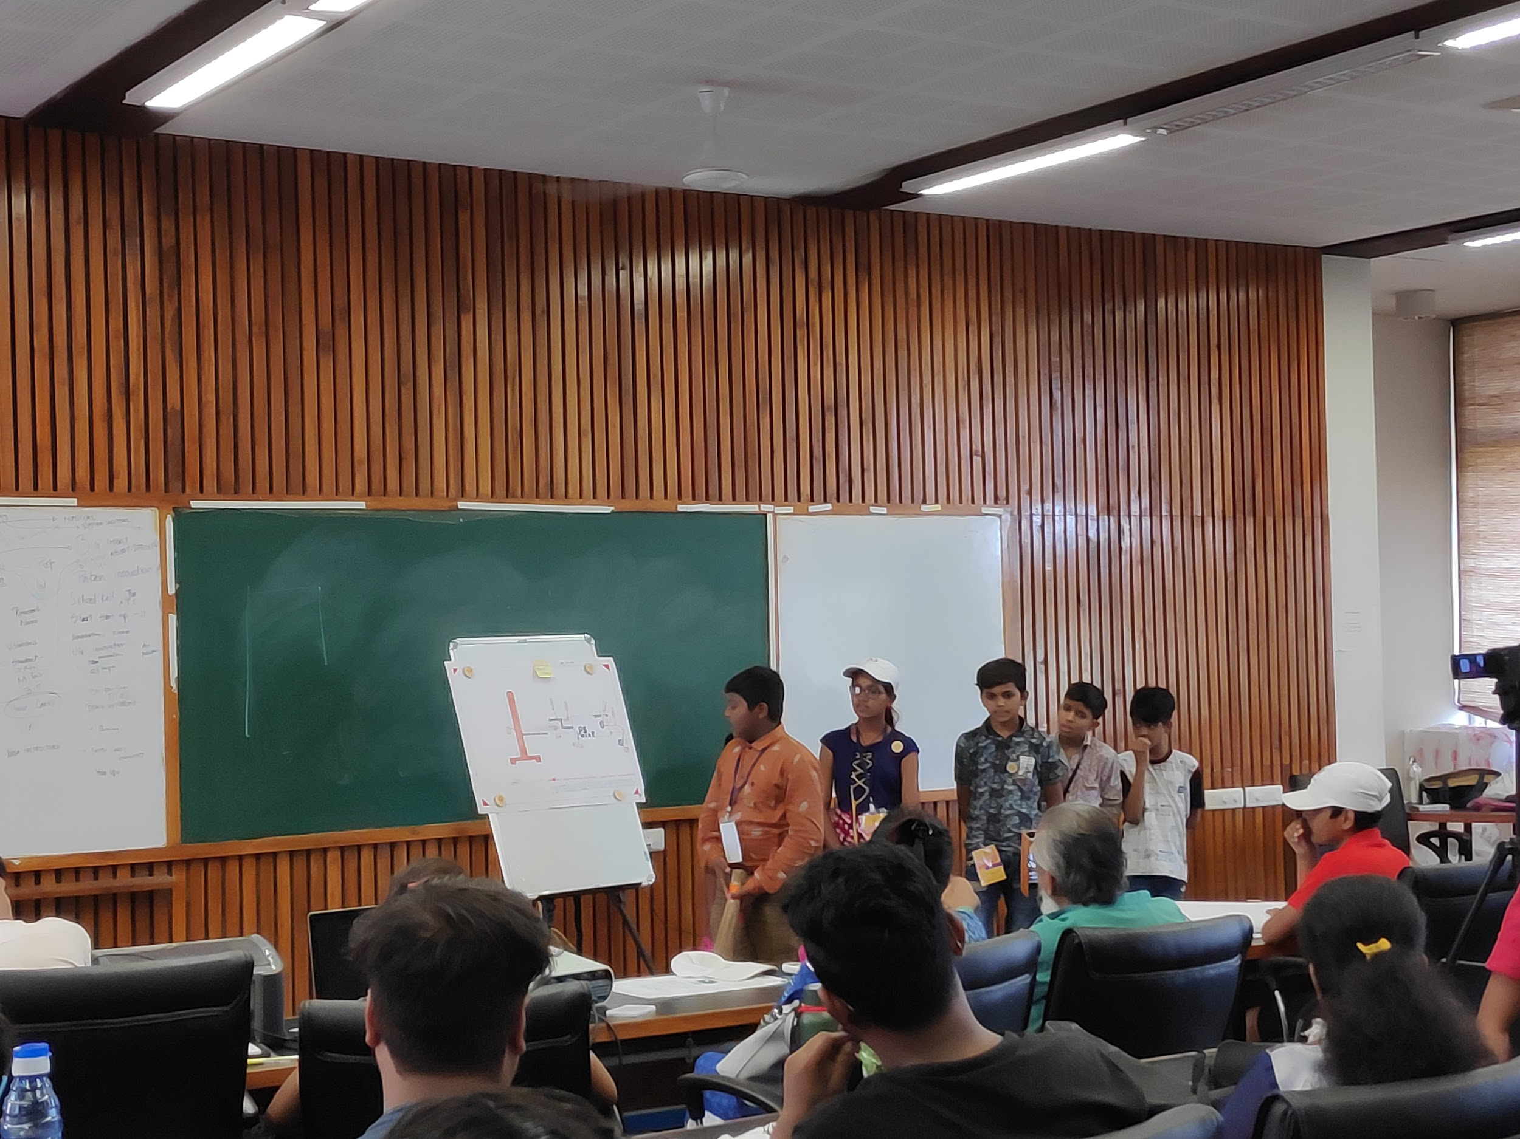

- SRISTI Team
- Broom Bundle Sorting Machine (Concept)[Heavy brooms]
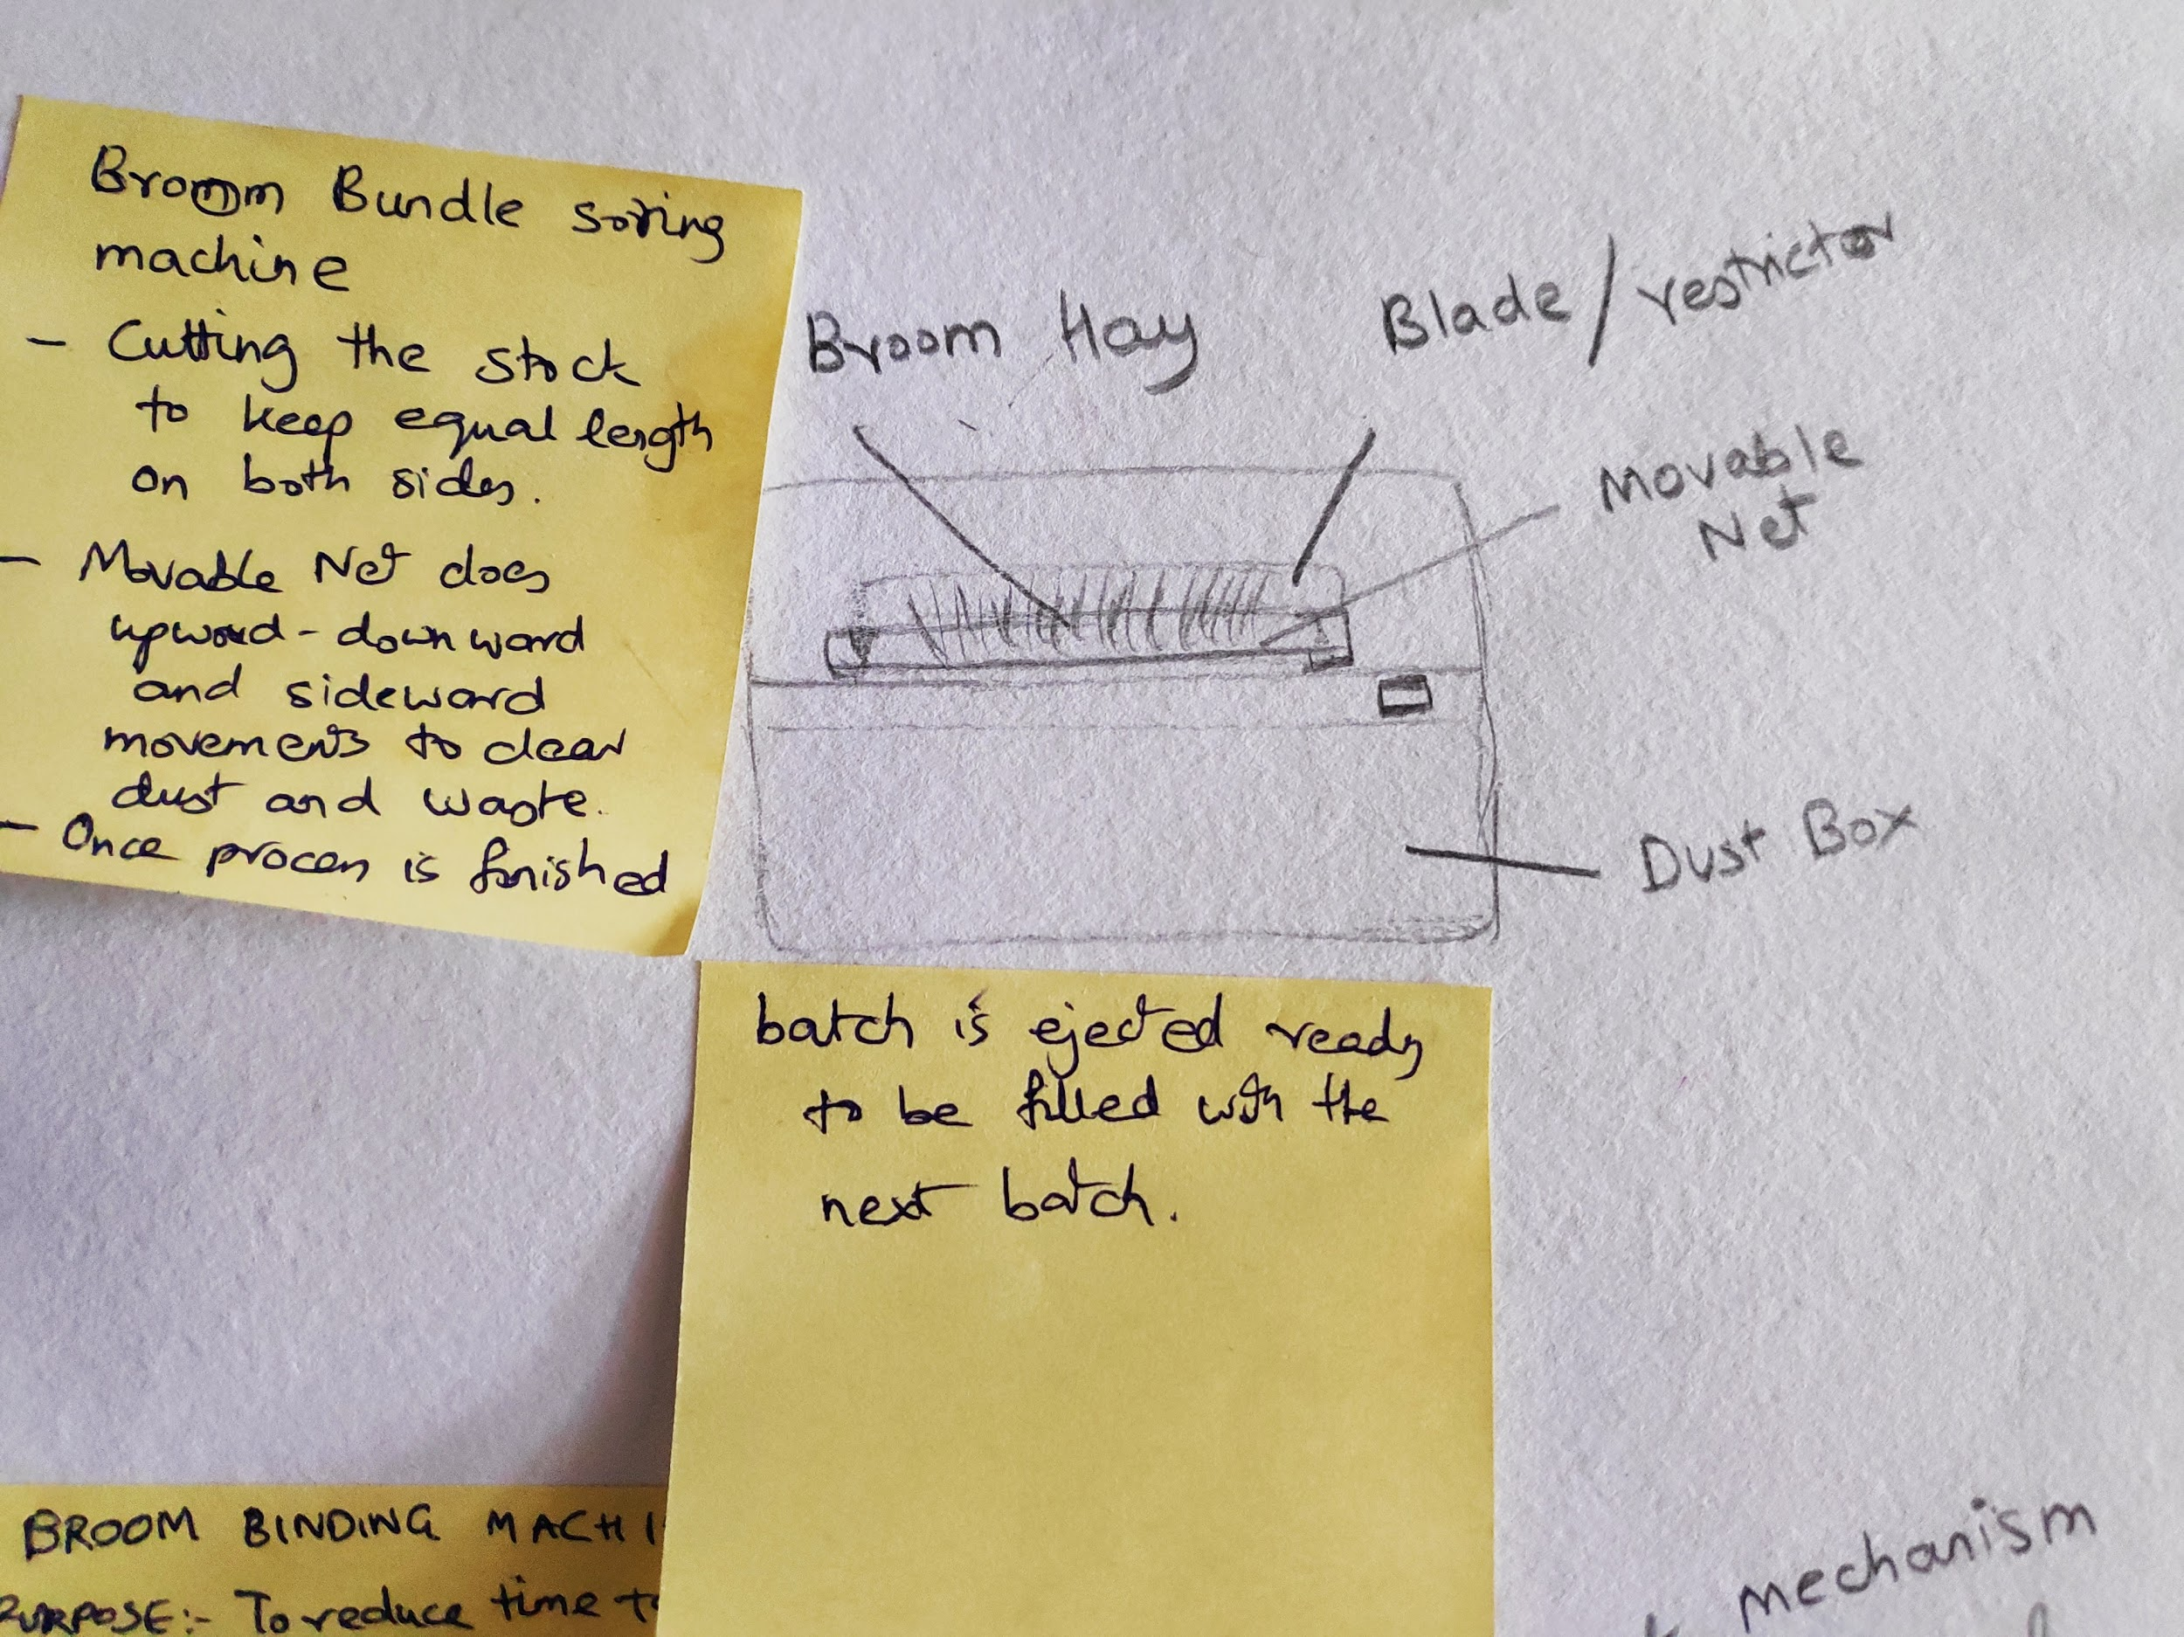

Things Required: Movable Net, Removable Dust Box, Openable Top for the machine, 1 stopper and 1 cutting blade

Mechanism: As you put the Coconut hay into the machine there will be a stopper engaged on one side as to keep all the hay bases at the same level. Once it is done, a cutting blade will be engaged with a switch as a part of the startup process of the machine on the other side of the hay ensuring all of the hay is now of approx. equal length. Once it is done, the movable net will start making alternate upward-downward and sideward movements every 5 or 10 cycles depending on the requirement for a fixed amount of time. Once it is done, the batch will be ready for broom making and the next batch should be ready to be filled.

2. Modification for the sorting Bucket (Heavy Broom)

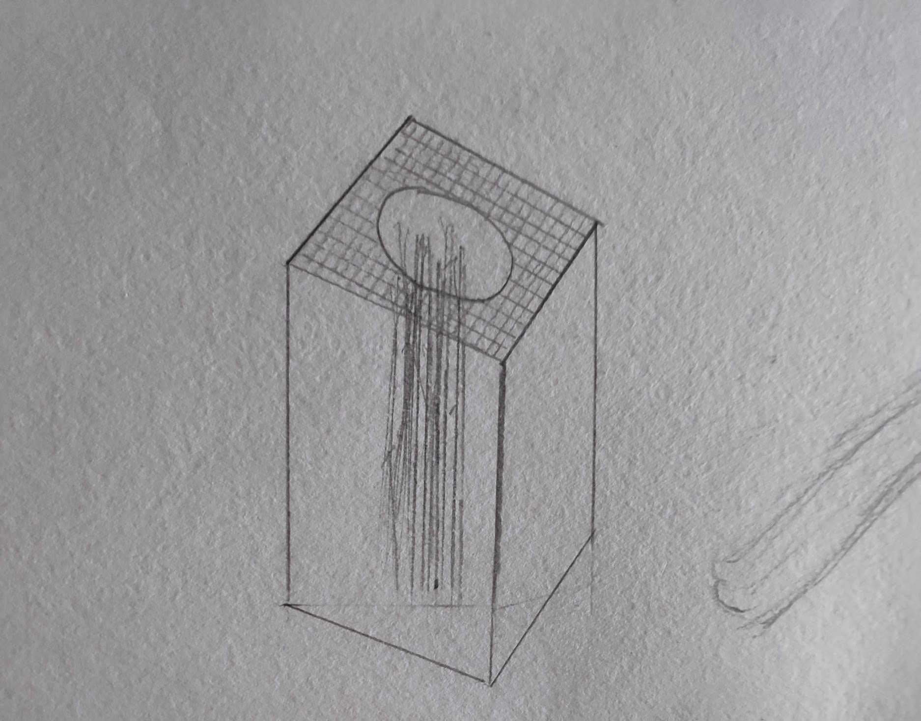

The bucket used for dusting and sorting the bundle is open on top and has no dust protection for the workers using it. So a very simple solution is including a cap on the bucket with a small cutout just for the bundle to pass through so that dust does not fly out.

3. Dust Remover disc (For home brooms)
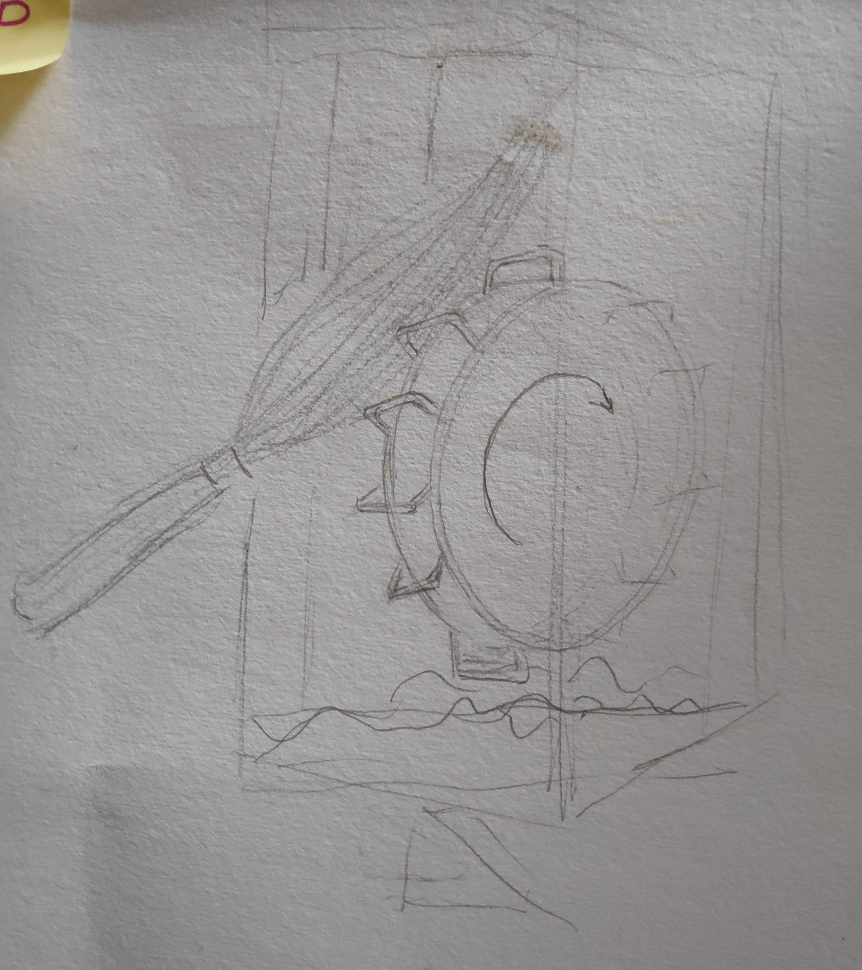

There is a rotating disc with U-brackets on its periphery, inside a closed transparent box which is manually operated on foot and the top part is openable with an open cut out for the palm leaves to be kept in for the dusting. As you keep the palm leaves on the rotating disc, dust settles on the floor of the box and the closed top doesn’t allow it to fly out.

4. Cut and Piercing Resistance Glove

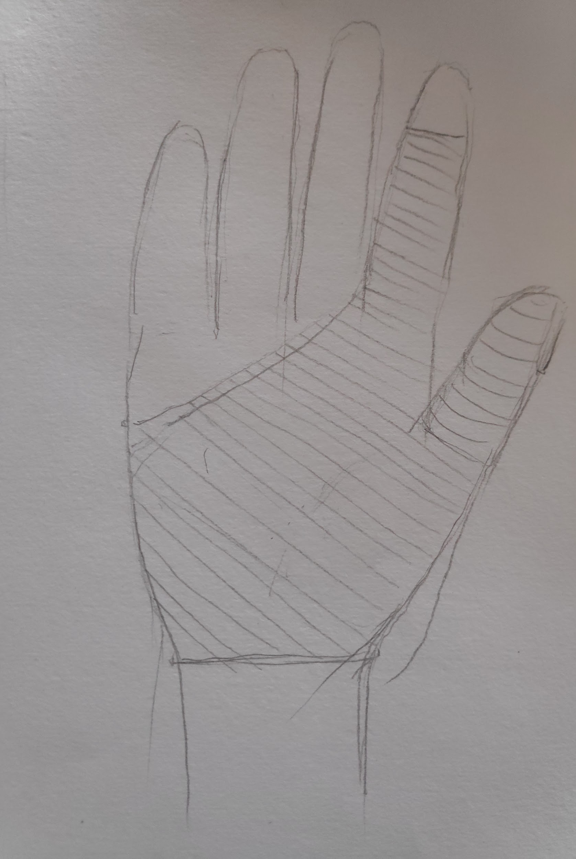

This is our proposed glove to be worn while handling coconut hay and winding wire to bind the broom together. We had noticed that a lot of the workers had received cuts and bruises on their hands due to the splinters from the coconut hay and the usage of wires for binding the hay by hand. This glove aims to solve both of these problems. It’s made from Polyurethane fabric as the primary material which gives mechanical resistance and piercing resistance and is further reinforced with Fiberglass (E-glass) and HPPE (High Performance Polyethylene) the latter of which is extensively used as a cut resistant material. The goal of this is to keep the cost low, hence Kevlar wasn’t considered as an option even though it has better than polyurethane for the piercing resistance. The design is currently representational but will be updated as more and more hands on testing is done to understand the areas of high stress while doing these activities over long periods. This design also has pores to allow ventilation so that hands don’t remain too sweaty. The design is light, durable and strong and low cost.

5. Mechanised Wire Binding mechanism for Brooms

Jb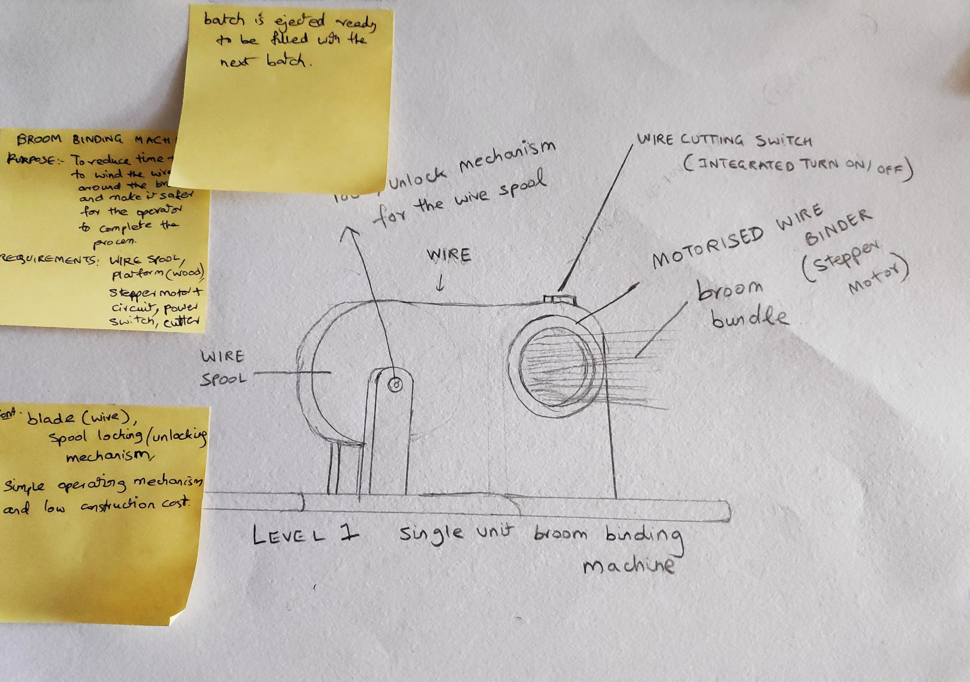

The inspiration for this design came from a tape cutting machine. There is a wire spool connected to a stepper motor wire binder with a hole enough for the size of the broom with reinforcing arms for holding the broom tight. As the procedure begins the stepper motor spins exactly the number of steps required to make the right amount of rotations to properly bind the wire around the broom and at the end of the procedure there will be a smaller motor along the top to twist and lock the wire around the broom. The goal of this machine is to reduce the time taken to bind the wire around the broom and make this scalable to have multiple of these machines running at the same time increasing the output and the wages of the workers in the shops.

6. Simultaneous Broom Dusting and Sorting machine

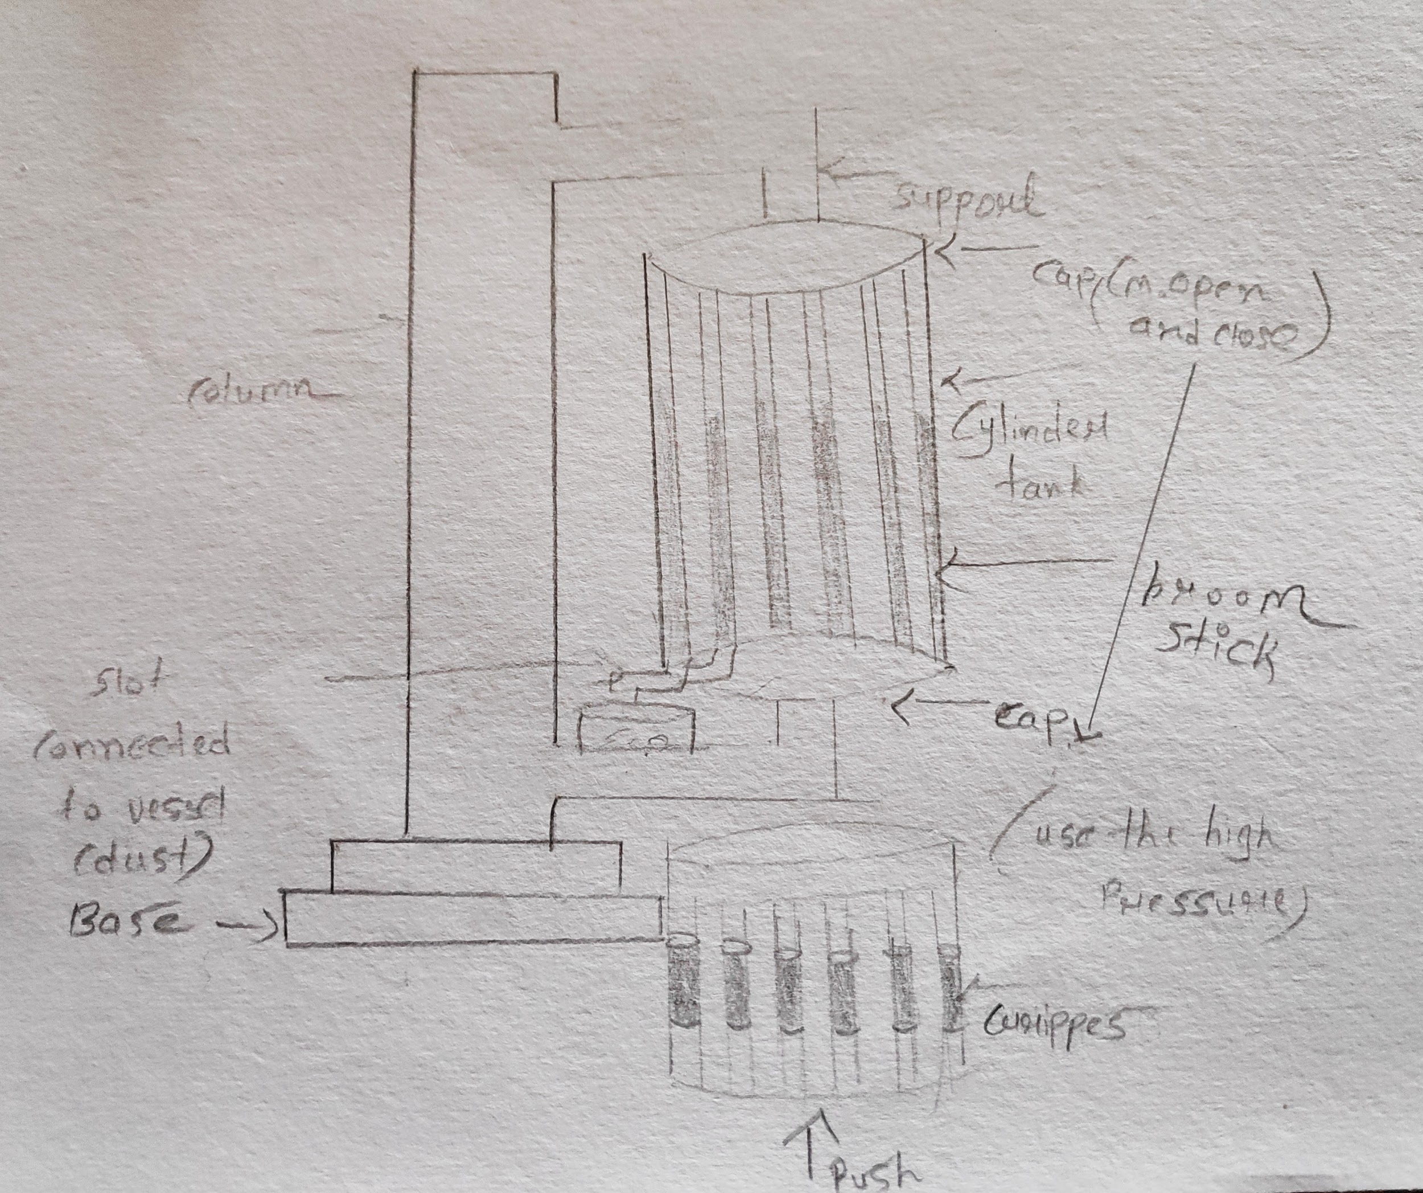

There is a rotating cylindrical tank placed vertically with 10 holes exactly the diameter of the brooms required for bundling the wires which are connected to a foot pedal with a bevel gear mechanism. It’s closed on both sides with a dust tank at the bottom. As you rotate the pedal for a few cycles at a considerable speed, the brooms get cleaned and dusted. The goal of this is to increase the efficiency and output of the workers making these brooms and this one does this by increasing it 10 times. This will hopefully improve their wages and make their lives cleaner and healthier which will further improve their productivity.

7. Forming Unions
The team noticed heavy competition amongst the small scale broom manufacturers. This not only led to very low broom prices, but also led to unhealthy working hours for the worker. And even after a really long and tedious working hours their profit earned was up to a bare minimum.
The team also noticed that the prices of the raw materials(plastics, metals etc used for the handles of the brooms) were quite high as they were not being manufactured locally in Ahmedabad. The price of the manufacturing machine of such parts is very high and quite unaffordable for a single shop owner to buy.
The team proposed to bring all these broom makers together so that they can form a union of themselves to pool their resources which will allow them to get enough funds to buy the manufacturing units for the handles and other materials which can increase their efficiency as well as their income.
Being in a union, they do not have to fight amongst themselves and consequently can also raise the prices of their brooms to earn a higher profit together.

Field Visit - II (Sculpture Industry at Gulbai Tekra, Ahmedabad)

Field Description

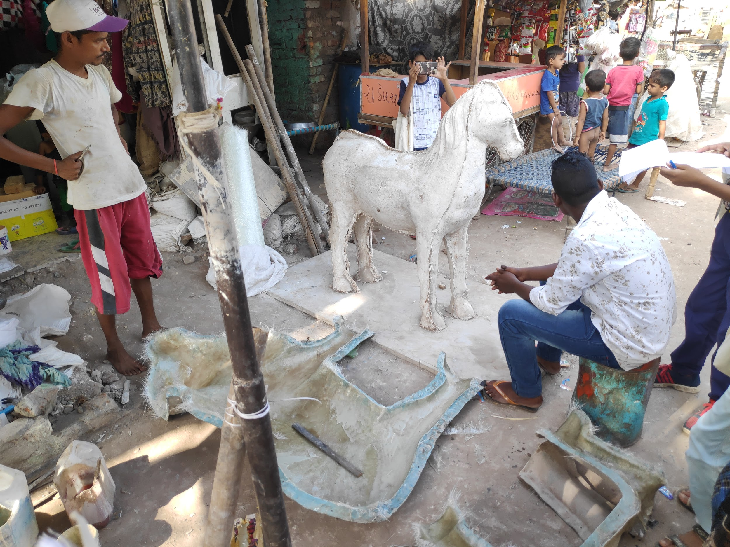

We visited the Hollywood of Ahmedabad at Gulbai Tekra, Ahmedabad. There we saw how sculptures were made. We visited two different sculpting shops. The first one employed usage of moulding clay (Clay + Limestone + Calcium/Magnesium Oxide)for making moulds to sculpt models of horses (that was the order that they were working on at the moment). They used this mould for making final models out of FRP which is made with fiberglass and epoxy resin which was done right inside the house where people lived and breathed the smell coming from these models. The workers still used it to make models. Once the moulds were set they used them to create more models out of POP.

Then we went on to the Ganesha sculptors who were utilising rubber moulds to create models for the upcoming Ganesh Chaturthi celebrations. They were in the process of creating the initial mould. The rubber was obtained by melting tyre pieces and was applied gradually to the initial model made out of clay. Once the outer layer of rubber has dried, they proceed to cover it with POP to create a mould. The process of creating the mould was more of an art than just a manufacturing process. The mould can then be used to create models. The smaller parts of the Ganesha were made from similar moulds and then were later attached to the larger piece to complete the model.

List Of Problems
- The workers generally worked at homes and still didn’t bother to care about the harmful fumes generated from the chemicals they were using. The heat of the season also made it uncomfortable for them to use masks.
- The sanding on the models was also done at the same place manually and released a lot of dust along with it. Manual sanding takes longer time and thus there is a longer exposure to the dust. The dust is harmful and has chemicals which could settle in the lungs and pose a threat for not only the workers but also the children.
- The sculptors used illegal and environmentally unfriendly material(limestone reinforced clay) for creating models, the usage of which is banned due to its polluting nature.
- There is unnecessary competition amongst multiple shops sculpting idols which reduces prices even further and puts more financial strain on shops and workers.

Solutions
Kids
They had noticed that during the model making process, the smaller parts had to be made from smaller moulds, and in a larger number. So they had proposed a machine that would easily manufacture all those small parts for quicker production of the models.

The Sristi team
- Upon noticing the reluctance of the sculptors to use eco-friendly clay, the team had proposed a new sort of material to be discovered that would be strong while at the same time really cost effective and eco-friendly, so as to not harm the environment.
- The team also noticed that the workers were not aware of the harmful fumes that the chemicals they used were giving off. Moreover as most of these shops were home based their children were also around and were almost under continuous exposure of these harmful chemicals. The team could not devise a solid solution solution for this problem.
- The unnecessary competition amongst the sculptors was something the team noticed and came up with a solution to form unions of these small scale workers, where they can easily pool their resources, get financial help, safety tips and also help from avoiding any further problems. Forming unions will give them a chance to raise the prices of their statues and sculptures.

