Sensor to measure the nutrient level in the agricultural fields
May-June 2017, Grambharti, Gandhinagar
By –
Iftak Hussain (Tezpur University)
Shubham (IIT Delhi)
Abhishek Dubey (Nirma University)
Aabhas Kedia (Thapar University)
Bodhisattwa Sanghapriya (VSSUT, Burla)

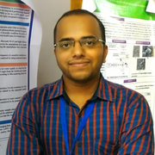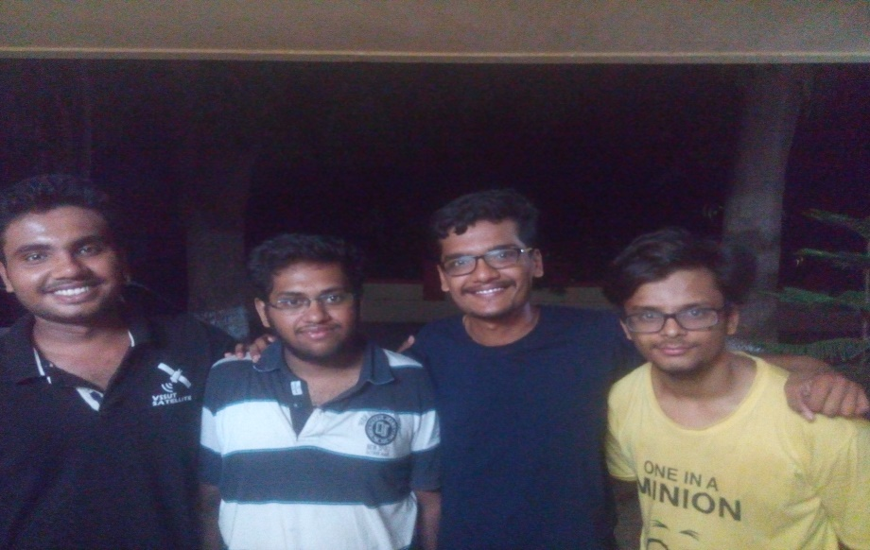
Team Members
We are a team of students from different states with different educational background but we have tried to solve a common problem which may significantly help our farmers. We have developed a low cost, robust sensor which can detect nutrients level in soil. Early knowledge of soil nutrient level can significantly help the farmers to use proper fertilizers on time which promotes proper growth of their crops and save their money on unneeded fertilizers.
Most of the farmers are from rural and remote areas of India. These regions do not have any proper soil testing laboratory facility therefore, the use fertilizers on their farming fields with their experience and intuition. This would result in uneven presence of minerals in different areas therefore, different areas have different deficiencies. This leads to stunned growth of the plant. So, we planned to develop a low cost, robust sensor which can possibly help to detect the soil nutrient levels, which eventually help the farmers to add the specific nutrient required in his farm.
After that, we went to the farmers to know what the problems exactly are faced by the farmers. There we got to know that farmers mostly use nitrogen and phosphorus fertilizers. So we targeted our first mineral to be phosphorus. Then, we searched for the existing technologies that existed for nutrient measurement in the soil. These are the two methods we found:
- Opto-chemical: using chemicals and colorimeter
- Electrical: using probes and sensors
For opto-chemical method, we are currently able to detect phosphorus content. We create a solution by adding some reagents to the soil extract and based on the concentration of P is the blue intensity of the solution. We developed a spectrometer that uses the camera of the phone to calculate the intensity of light passing through the solution. An app was developed to calculate the intensity. Using this intensity, app calculates the concentration of P content in the soil using the calibrated graph already inserted in the app. This same method can be used to calculate the nitrogen content in the soil and also the pH of the soil.
In the electrical method, we made a probe using which conductance and capacitance value is calculated which helps us to get the moisture content of the soil. Also by calibrating it we can get the total mineral content present in the soil. By subtracting the above 2 major nutrients, we can get an overall idea of mineral content of rest all nutrients.
Problem Statement:
“To make a sensor to measure the nutrient level in the agricultural fields.”
Initially our problem statement was to develop a probe to measure micronutrients in the soil. But after taking to the farmers, we got to know that no farmer gives their soil for testing. They just used there intuition to decide the amount of fertilizers in the soil. Most of the farmers used phosphorus and nitrogen fertilizers in their soils. So we are trying to develop a system that is portable and also cheap and affordable which can help farmers realize which nutrients are necessary for their soil at what moment. So we decided to make our primary focus should be on calculating the amount of nitrogen and phosphorus content in the soil.
Mind-map:
Initially, based on our prior art search we made the first version of our mind-map.
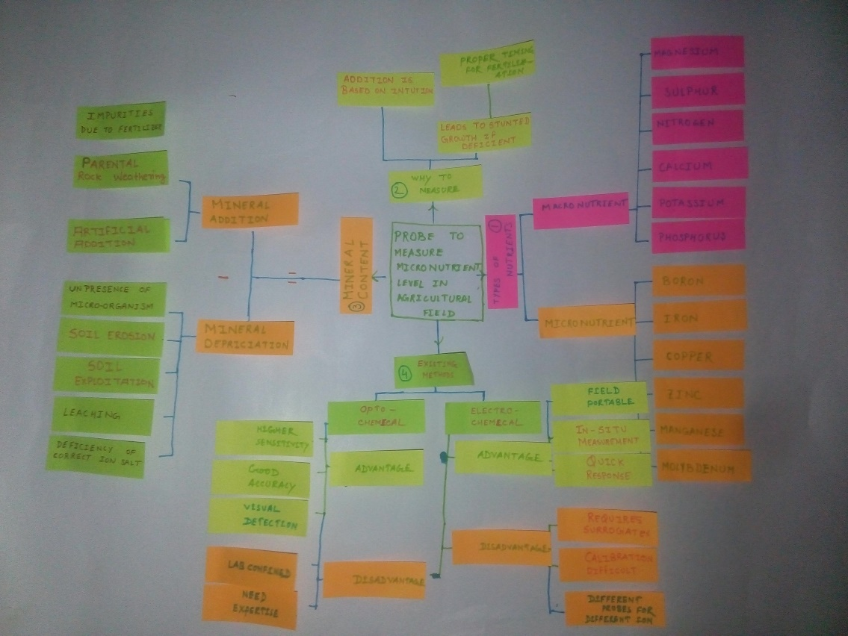
Version 1
It had 4 parts:
- Types of nutrients: This lets us know about our target nutrients that we will have to detect.
- Why to measure nutrients: When we approached why we need to measure, we got to know that there are some places where there are no soil sampling laboratory. So they add fertilizers based on intuition.
- Mineral content: Then we tried to approach the problem what is happening to the minerals that are already present. So we studied how minerals get added and get depleted from the soil.
- Existing technology: Then we searched regarding the existing technologies that are already in the market. So there we found 2 methods – opto-chemical and electro-chemical methods.
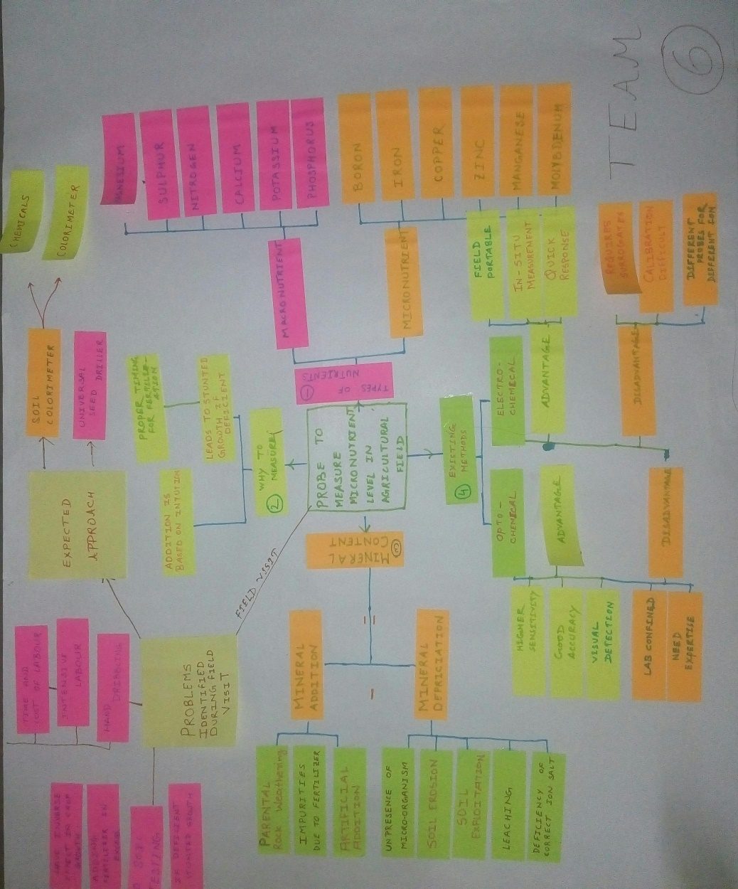
Mind-map version 2
Then, after visiting and talking with the farmers and knowing their problems we made some changes to our mind-map. We added a branch of problems. This is our version 2 of mind-map.
Field Visit-Amrapur village:
On 29 May, we have visited a village Amarapur, near Grambharati, Gandhinagar to know the problems of our farmers regarding on time fertilization and their effects on the overall growth of crops. About 9:00 am we have reached our destination having the sun on our top. It is too hot and the farmers were working without any protection from sun then we realize the pain behind each roti.
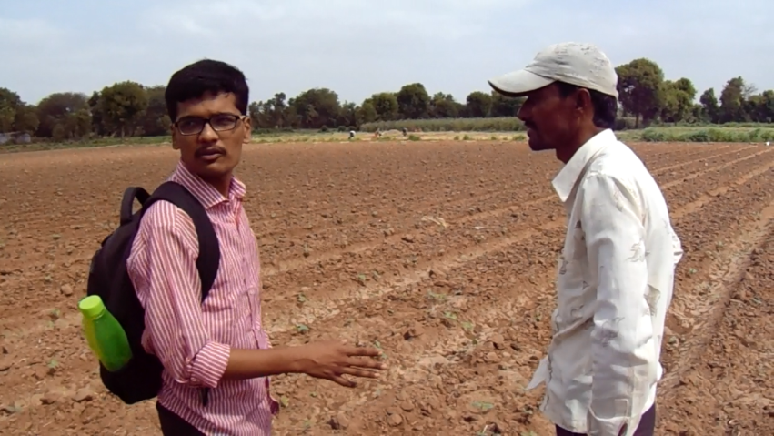
Talk with Mr. Mahendra
When we reached in one of the farming fields, we have seen a young man is busy with his passion to feed us. We hesitate to approach him since he is working, but when he saw us waiting for him, he eventually stops. The man was Mr. Mahendra Rathore, a young man around 40 years in age. We introduced ourselves and when he knew we are from Grambharati, he became easy with us. We have asked him about the problems that he was facing in his fields. We didn’t approach the farmers with only the problems related to our problem statement instead we asked them, what problem do they expect us to solve for them. At the same time seed sowing for cotton was going on, they were sowing seed by creating a matrix through the thread the process was called hand dibbling with workers first spotting the place and then dropping 3-4 seeds at each spot. Farmer Mahendra Rathore replied that such labour-intensive process of seed sowing in farming should be replaced by affordable automated techniques. Then we asked him why he uses hand dibbling method instead of using tractor drilling methods to sow seed as that method is much faster, cheaper and requires almost no labour to which he replied that the problem is the seed spacing. Available tractor based drillers have fixed horizontal spacing and the vertical spacing adjustment is also very limited which makes seed drilling automation not useful for his required crop. He mentioned about the problem of market value for his crops. Also, he created water channels so that water can automatically spread across the field.

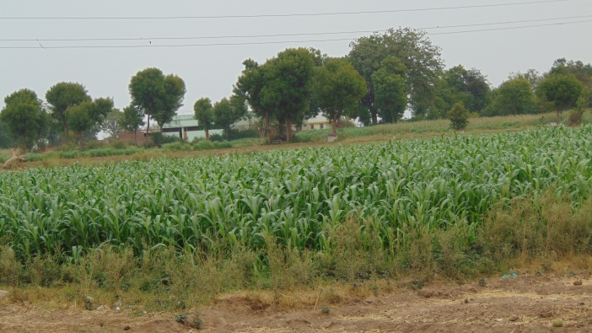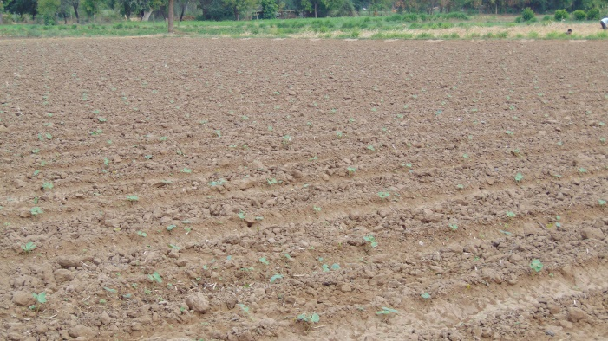

Fields of Amrapur

When we asked him about how he judged the amount of fertilizers to be used, he told us that three years ago he took five samples from five different areas of his field and went to Gandhinagar for testing with the help of Kissan Soil Card. After 10-15 days, he got the result and it said that these result were valid for 5 years. So based on that result he used the fertilizers in his field. He specifically told that he used zinc (Zn), manganese (Mn), magnesium (Mg) by dissolving it in water and circulating it in the water channels so as it reaches all the plants uniformly. When we asked why not use nitrogen (N) and phosphorus (P) fertilizers as they are major nutrients needed by the plants, he gave us a very good example to relate with. He said “ When you go to a wedding you do not eat plain rice and dal but eat something special. Similarly, nitrogen and phosphorous are something plants get regularly, we need to specially provide zinc and manganese.”
We also talked to Mr. Mahendra’s brother regarding this. He also said the same thing. He also added that using too much fertilizer has never been seen as a problem to him so if he adds excess it is no problem for him. He also told that he grows bajra, juhar, kapas (cotton).

Next day, we have visited the fields of Mr. Bharat Jivan Rathore which was near to the previous fields. He also mentioned us the problem of labour -intensive process of seed sowing instead of using the tractor as he needed the proper seed spacing which was not fulfilled by tractor. We asked him about the sampling procedures that he follow, he told us that he does not sample his field soils. According to him, he just uses his own intuition and experience to apply fertilizers in the field. Mostly, he uses urea (for nitrogen) and DAP (for phosphorous). He also added that using high amounts of these fertilizers destroys the fields and since DAP is expensive, he must be careful with its usage. He said that he mostly grows beans and bajra crops.

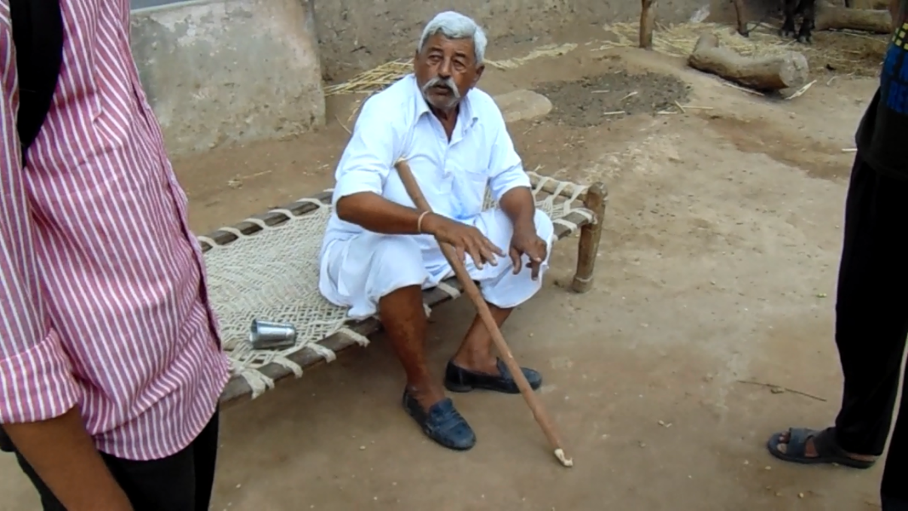

Talk with Mr. Bhardesh

After that we went to meet Mr. Bhardesh Sardarji Rathore, a known farmer in Amarapur. There he said that he never gave the soils for sampling since it takes time to get results from government authority. He said that he mostly uses DAP and urea, DAP would show slow effect but urea would show an immediate effect. He also said that he rarely used zinc fertilizers as he thought that it is not needed. He mentioned that he had a major problem with the attack of nilgai on their fields during night-time. So we requested the team working on the problem of warning and monitoring of the wild animals to visit them so that they can help him. He also mentioned the same problem of hand dribbling methods instead of tractor drilling methods.

We have also did a survey if every farmer we visited had a smartphone as we thought that one of our possible solution can have the need to use the smartphone. It is interesting to found that all the households carries a smartphone or at least know how to take a picture. But still the latest information and existing technology was not being used by them properly which our team was not expecting.
These are the problems that our team has identified:

1) Not sampling of soil:
Most farmers do not get there soil sampled or have got there soil sampled long back and use the fertilizers based on the intuition. This leads to either deficiency or excess of minerals in the soil leading to improper growth or damage to the crops. There is also the problem that once soil sampled, it is claimed to be valid for 5 years which is a very long time during which soil's content can change.
2) Usage of hand dribbling method instead of tractor drilling method:
Available tractor based drillers have fixed horizontal spacing and the vertical spacing adjustment is also very limited which makes seed drilling automation not useful for specified crops. There are very few drilling techniques and those are too seed specific and land specific, hence couldn’t be used on a larger scale. Due to this reason most seeds are still hand dibbled which consumes more labor requires expert supervision and hence makes the overall process of cultivation expensive and time-consuming. We require a “Universal Seed-Drilling Technique” that should cover the maximum possible spectrum of seeds and should allow spacing according to farmer’s requirement and should sow seed accurately independent of the speed of tractor or bullock-cart.

3) Attack of nilgai :
Many farms had a stand installed in there fields which were used at night to watch for nilgai attack. Some farmers also told us that these attacks are a regular problem in that area. So we contacted the team working with this specific problem to consult with these farmers.

Design Concept:
We initially thought of using only the colorimeter method to measure the concentration. Spectrometer design was been done in CAD model to make it compatible with the phone size.
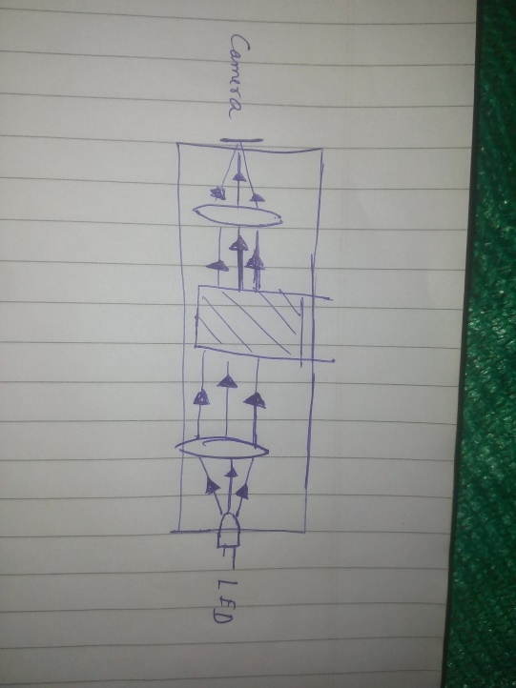
Principle of spectrometer
We targeted phosphorus and got all the chemicals required to make the reagents. We did extensive research and also tried in the lab to see if we can make the experimental process feasible at the field itself. These were the steps that we followed for making the final solution that will be used in spectrometer.
- Take 5 gm soil sample and add 2 ml of dilute HCl and pinch of ammonium fluoride (NH₄F). Shake well for 5 minutes and filter the solution.
- Take the extract liquid and add 5 ml of ammonium molybdenum ((NH₄)MoO₄) (made by adding 0.5 gm of ammonium molybdenum in 50 ml of water).
- Now add 5 ml of stannous chloride solution (SnCl₂.2H₂O)(made by adding 2 gm of stannous chloride in 20 ml of water)
- Filter the solution and then take the value in spectrometer.

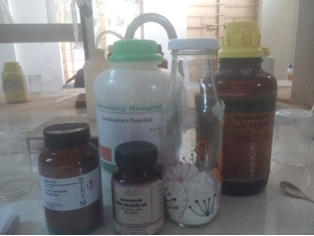
Chemicals Required
The calibration value can be taken by making a solution of calcium phosphate – adding 0.2 gm of it in 20 ml water and take 5 samples – 1 ml, 2 ml, 3 ml, 4 ml, 5ml of it and adding water to make it a 5 ml solution and repeating the above procedure from step 2.
Similar method exists for the measurement of nitrogen solution (both the nitrate form and the ammonium form). But the chemicals required for this process are not easily available. It takes nearly 1 week to get those. Since we did not have that much time, we had to drop that idea for now.
The app design was also started in parallel for the spectrometer so as to calculate the intensity and calculation for the calibration graph were being done to include it in the app. The app reads each value of the pixel by reading the RGB values of each and then finally averaging it gets the intensity value.
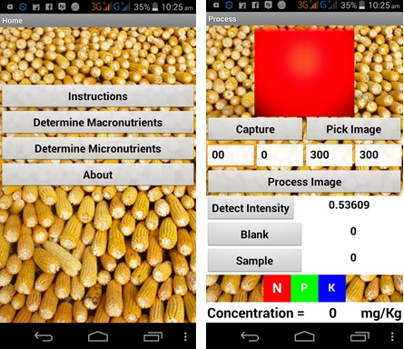
App outline
After few days, when phosphorus measurement was seen to be almost complete, we thought of approach the problem with electrical method also. So we started doing some research and making a probe so that conductance and capacitance value can be achieved.
Prototype Making:
We made only one design for the spectrometer. The CAD design was made and then using a 3D printer the body of spectrometer was made. Then, we attached a 2 lens inside the body, one before the solution and after the light to make the rays of light parallel and the other lens after the solution and before the camera of the lens to make the light convergent on the camera. The LED most suitable for use of this phosphorus solution was of 680 nm.
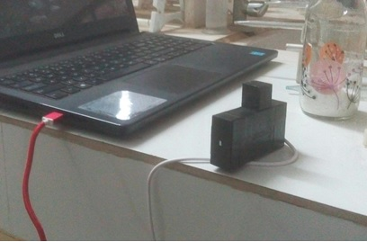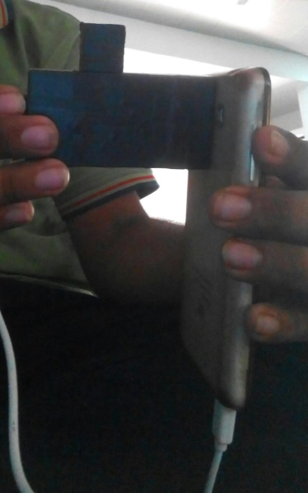
Mini-spectrometer
App was designed to read the data from the camera and read the intensity value by calculating the RGB value on each pixel and then averaging it. Calibration value was already involved in the app itself. There were many changes made in the app to ease for the user to use it.
Different intensity photos from camera
The design of the probes was the difficult one. Initially, we used thick iron rods as probes. But the value of conductance became too low because of the potential becoming too low as it got distributed among the rod. Then, we designed a thin copper rod by folding the copper plates. Conductance value started coming but the capacitance value started to give a huge deviations. So finally, in our final version we used nails and covered it with a copper plate. The values of the conductance and capacitance got stabilized and we made this our final design.
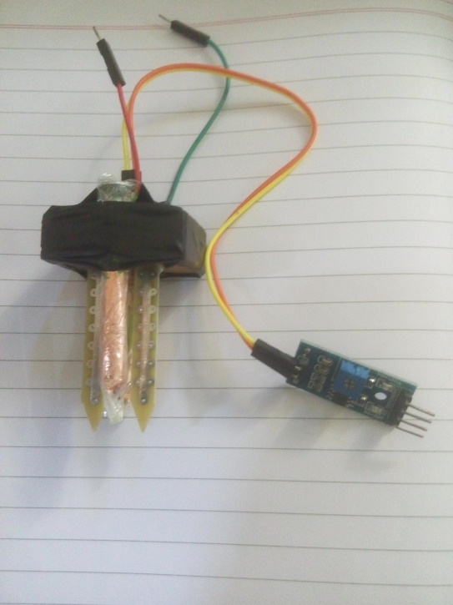
Final design of the probe
Bill of the material:
S.No. | Material | Quantity | Cost(Rs)
1 | RGB LED | 2 | 10
2 | USB cable | 1 | 50
3 | Phone-USB connector | 1 | 50
4 | 3D printing material |  | 400
5 | Test tubes and cuboid tube | 2+1 | 500
6 | Probes | 4 | 200
7 | Arduino Uno | 1 | 400
8 | Bluetooth module | 1 | 300

Limitations:
For the opto-chemical method in which spectrometer was used, we did an extensive lab experimentation to determine the factors and conditions that can lead to the failure of getting a better result. These are the results:
- Filtering of the solutions should be done with a very fine filter paper which would be slight difficult to do in the field itself.
- There is unavailability of distilled water with the farmers.
- Adding of reagents should be in proper order one after another only, else results will be wrong.
- After final solution is prepared, filtering is still required or else the intensity value will become high due to the colloidal precipitates formed.
- The complete process needs a stable environment to perform the experiment as we do not want the interference of the colloidal particles that might have slipped through the filter paper.
Similarly, there are some limitations to the process in which probes are used. Since there is not much work done on this technique (due to unavailability of time), we still could not manage to find the micronutrient level.
Road Ahead:
There are many possibilities ahead to do the work for us. There is still work to do upon nitrogen detection and calibration. Also, proper calibration of the probe is still left. Currently we are only getting the absolute values but we have to properly calibrate and find a correct correlation to get a correct value. We also need to find a proper and robust, in-situ chemical techniques which can be handled properly by farmers also. There is still a great scope of work that can be done using the probe which is yet to be explored.

