Final Report:
Project Name: Honey Bee Network WebApp
Team Members:
- Tanuj Vishnoi
- Divgian Singh Sidhu
Date: May – June 2017
Location: Grambharti, Gandhinagar
Summary:
On 26th May, 2017 we were given a task of making the Honey Bee Network (HBN) WebApp. This seemed like a very difficult task and for 2 days we looked at the problem and figured out what to do and how to do it which was followed by making the first mind map. The main problem was that, the present HBN website was not focused on the main fundamentals of the Honey Bee Network i.e. to bring innovators and their innovations to limelight and also there was no admin portal through which latest data could be added. The last update of the website was from 2015 so we decided to make a completely new website using a much secure platform i.e. Django to make the website which uses HTTPS2 security; HTML5, Bootstrap3 and Material Design Lite for the design part. Then we were provided with a list of demands we had to meet inside the app and thus, decided to make 6 main pages which would then lead to further subpages –
- The Homepage
- Innovations
- Activities
- About Us
- Magazine
- Forum
The first 4 were accomplished completely until 8th June with our prior knowledge and help from Google, YouTube and Stack Overflow etc. For the magazine part, we found that the platform ISSUU was already hosting the magazines published by the network and it is a very user-friendly platform. Thus, we integrated it with our website and the magazine bar leads to a link to this website. The last part is something we are not proud of as that is something which we could not do but have planned to keep working on; will be completed in a few weeks.
The softwares we used are explained hereby: Django is a powerful python framework for creating dynamic Web Application. It offers many security features like HTTPS level security of security for database management; CSRF (Cross Site Request Forgery) Tokens for securing the user form and profile data from DDoS attacks; Dynamic Website Creation: Automatic generation of pages and URLs by the use of iterations and conditional statements. Bootstrap3 is an efficient combination of JavaScript and Cascading Style Sheets library, making efficient handling of websites for different devices like Tablet, Desktop and all Mobile Devices. Google Material Design Lite is a designing tool for website to make it more responsive and user-friendly. It is also a combination of both JavaScript and CSS library.
So, this was our journey- a little hard, a lot of fun and a lot of learning.
THANK YOU

Problem Definition:
The present HBN Website has a list of all the activities happening around the network, newsletter, join us etc. But it is missing the platform to fulfill the basic motive that the Network was made for: bringing innovators and their innovations together and bring them in the limelight and also there was no admin portal through which latest data could be added. In the present website, the last edit was in 2015. Thus, we felt that a completely new website has to be made to take care of the following points:
- Make an admin portal for the easy handling of the website.
- Make a database of all the innovations.
- Make it easy for anybody to submit their innovation.
- Make it easy for the network to spread the news of the activities and events happening around the globe.
- Make the community more formal, as presently the network is very loosely bound.
- Make user profiles to help the network communicate with each other.

Mind Map:
Version 1: -
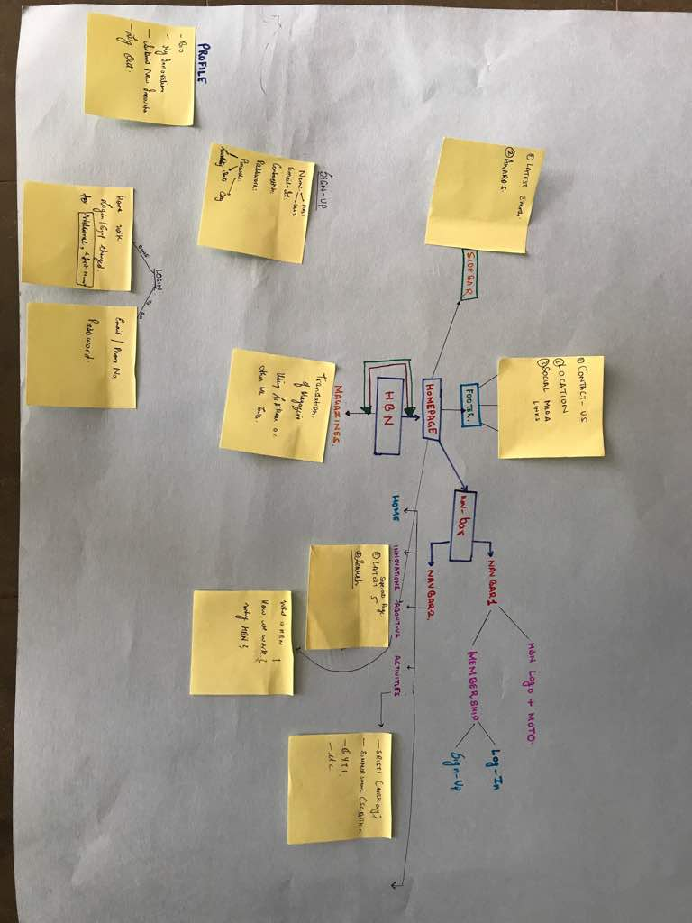

Version 2: -
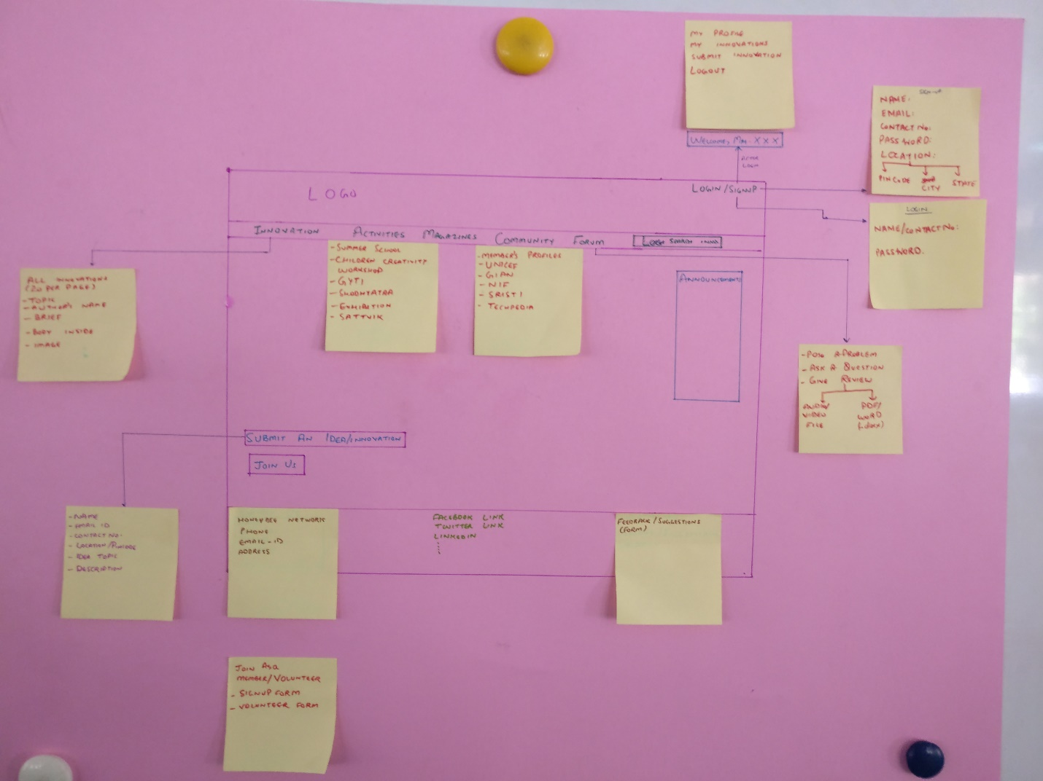
Road Ahead: -
- A proper Forum needs to be developed so that people can post their queries and questions.
- A magazine based platform is to be developed which will include features like buying, subscribing HoneyBee network magazines in different languages.
- This will also provide an opportunity for users to volunteer to translate the magazines to their respective languages.
- Users can access and edit their innovations on their profiles.

